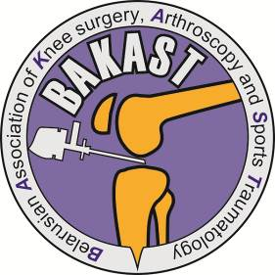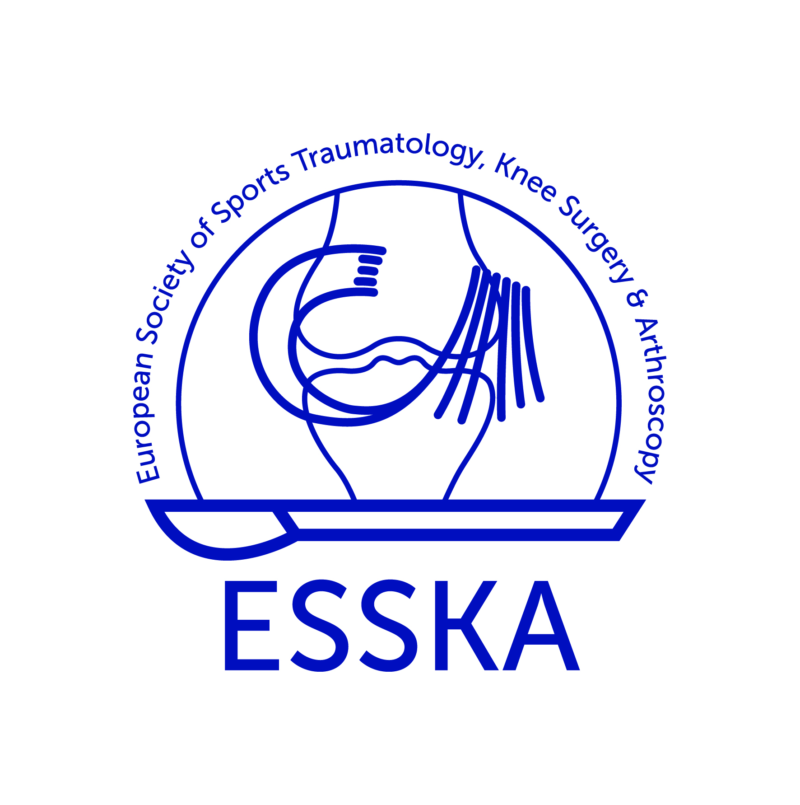

PROGRAMME

3rd International BAKAST Congress
«Arthroscopic and Minimally Invasive Surgery of the Shoulder Joint»
(19 May 2017 Minsk, Belarus)

Location: National Olympic Committee of the Republic of Belarus
Radushnaja street, 27, Minsk, Belarus

08:00-10:00 | Registration
Moderation: | Beletskiy A., Eismont O., Randelli P., Strafun S.
10:00-10:10 | Opening Ceremony
10:10-10:20 | The Development of Domestic Arthroscopic Surgery  Eismont O. (Belarus)
10:20-10:30 | Cooperation between BAKAST and ESSKA  Randelli P. (Italy)
10:30-10:50 | - Diagnosis and Treatment of Chronic Painful Shoulder  Strafun S. (Ukraine)
10:50-11:00 | Rotator Cuff Tear in Athletes  Randelli P. (Italy)
11:00-11:10 | Transosseous Rotator Cuff Repair, Surgical Technique and Results  Randelli P. (Italy)
11:10-11:30 | Operative Management of Rotator Cuff Tears. Indications, Technique, Results  Franel J. (Poland)
11:30-11:40 | Discussion
11:40-12:00 | Coffee break
Moderation: | Gerasimenko M., Макаrevich E., Franel J., Skakun P.
12:00-12:10 | Treatment Tactics in Symptomatic Acromioclavicular Osteoarthritis  Il’in D., Коrolev А., Logvinov А. (Russia)
12:10-12:20 | Management of Partial Thickness Rotator Cuff Tears  Logvinov А., Коrolev А., Il’in D. (Russia)
12:20-12:30 | - Diagnosis and Treatment of Superior Glenohumeral Ligament Lesions (Pulley Lesion)  Strafun А., Bogdan S. (Ukraine)
12:30-12:40 | Long-term Results of Conservative Treatment of Rotator-Biciplital Complex Lesions  Savchuk А., Danilenko О., Макаrevich E. (Belarus)
12:40-12:50 | - Arthroscopic Rotator Cuff Repair: Errors and Complications  Strafun А., Bogdan S. (Ukraine)
12:50-13:00 | Portal Placement for Shoulder Arthroscopy  Il’in D., Коrolev А., Logvinov А. (Russia)
13:00-13:10 | Arthroscopic and Less-Invasive Shoulder Surgery  Piven U. (Ukraine)
13:10-13:20 | The Role of Hyaluronan in Management of Shoulder Pathology  Peresada А. (Belarus)
13:20-13:30 | Discussion
13:30-14:30 | Lunch
Moderation: | Kezlya О., Domzalski M., Murzich А., Lashkovski V.
14:30-14:50 | Shoulder Instability – Types, Diagnosis and Management  Franel J. (Poland)
14:50-15:00 | Posterior Instability of the Shoulder  Randelli P. (Italy)
15:00-15:10 | Biomechanics of the Shoulder after Latarjet Procedure  Domzalski M. (Poland)
15:10-15:20 | Shouder Instability in Terms of Rotator-Bicipital Complex  Danilenko О., Макаrevich E., Savchuk А., Маlashko А. (Belarus)
15:20-15:30 | Application of 3D Printing and Additive Technologies in Surgical Management of Recurrent Shoulder Instability with Significant Bone Loss  Vetoshkin А. (Russia)
15:30-15:40 | Rotator-Bicipital Complex Lesions in Instability of Long Head of Biceps Tendon  Danilenko О., Макаrevich E., Маlashko А. (Belarus)
15:40-15:50 | Algorithm for Diagnostics of Rotator-Biciplital Complex Lesions  Маlashko А., Danilenko О., Макаrevich E., Savchuk А. (Belarus)
15:50-16:00 | Use of Regen PRP in Orthopedics  Vencevicius R.( Lithuania)
16:00-16:10 | Discussion
16:10-16:30 | Coffee break
Moderation: | Eismont O., Zagorodniy G., Nikolaev V., Boloboshko К.
16:30-16:50 | Functional Results of Operative and Nonoperative Treatment of Proximal Humerus Fractures  Romanowski L. (Poland)
16:50-17:00 | Surgical Management of Proximal Humerus Fractures  Neustroev D. (Belarus)
17:00-17:10 | Surgical Management of Scapular Fractures  Strafun S., Gaiyovich V., Gaiyovich I. (Ukraine)
17:10-17:20 | Trapezius Transfer in Terms of Practical Anatomy  Divovich G. (Belarus)
17:20-17:30 | Interscalene Brachial Plexus Block for Shoulder Surgery  Pecherskiy V. (Belarus)
17:30-17:40 | Rehabilitation in Shoulder Diseases  Peresada А. (Belarus)
17:40-17:50 | Healing Treatment Features of the Musculoskeletal System in Athletes  Zagorodniy G. (Belarus)
17:50-18:00 | Discussion
18:00-18:30 | Summing-up of the Congress. Presenting certificates
18:30 | Dinner & Party

